Basic Hello World Web App using AWS

Step 1: Created a Web App

Created a web app with AWS Amplify console and deployed the changes. Below is the screen shot of the same:

Web Url: <https://dev.d19yubg6da652h.amplifyapp.com>

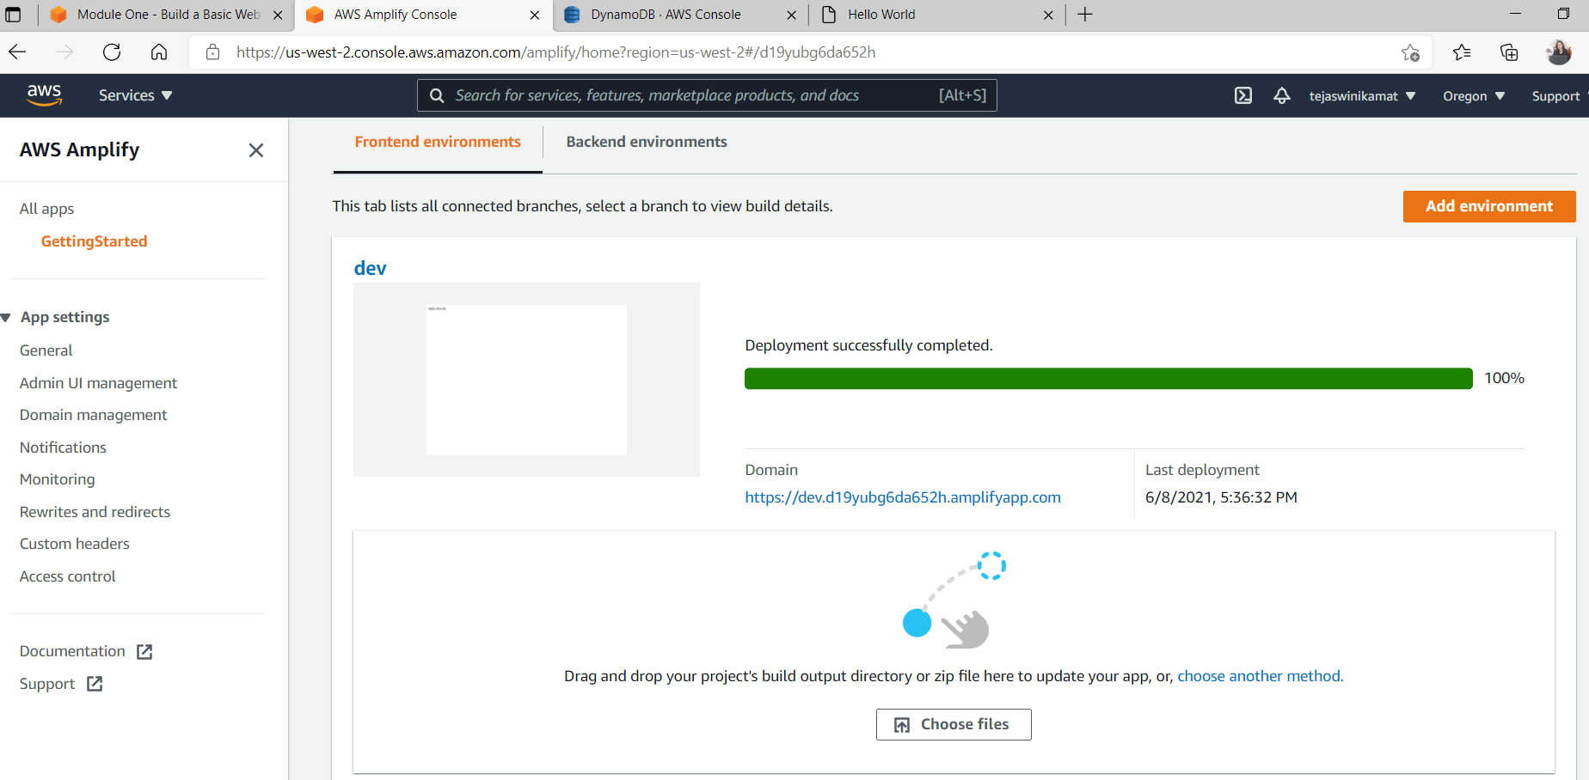

Step 2: Build Serverless function

AWS Lambda service is used to create serverless function. I have used Javascript language to code the function.

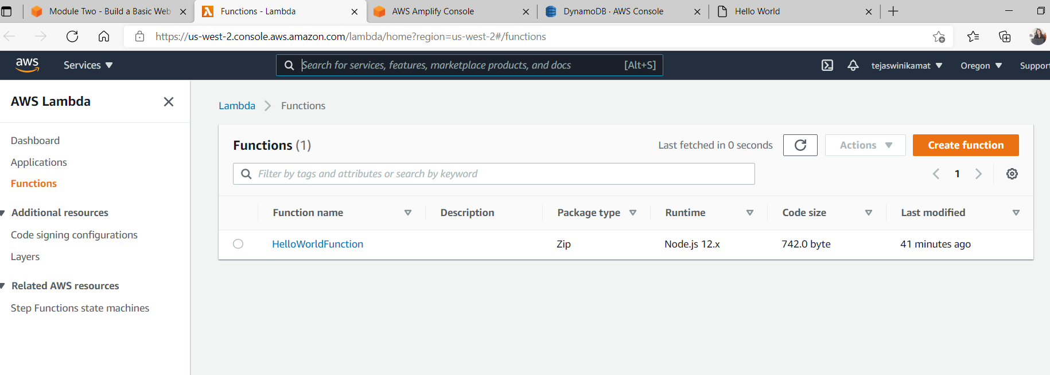

Step 3: Link Serverless function to web app

Amazon API Gateway is sed to create a RESTful API that allows me to make calls to my Lambda function from a web client. API Gateway will act as a middle layer between the HTML client created in step 1 and the serverless back-end created in step 2.

REST API URL created:

<https://aoxezfdib7.execute-api.us-east-1.amazonaws.com/dev>

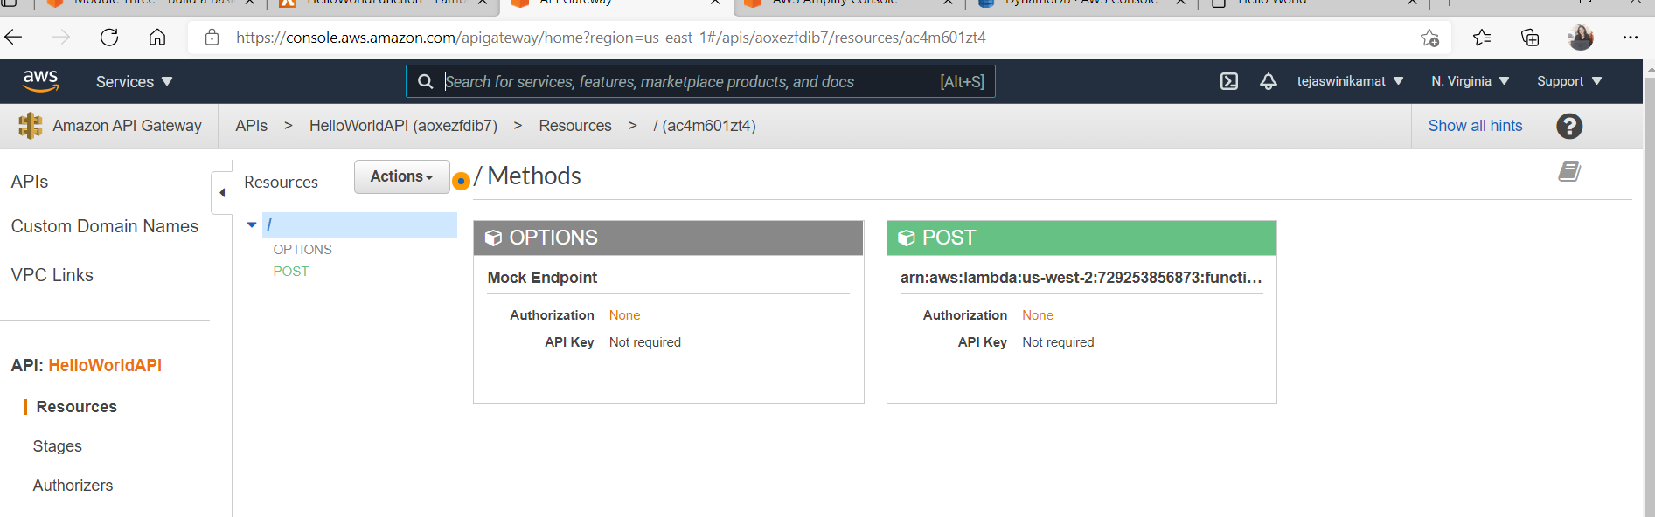

Step 4: Created DataTable in DynamoDb

Created a table to persist data using Amazon DynamoDB. And also created role and manage permissions with IAM.

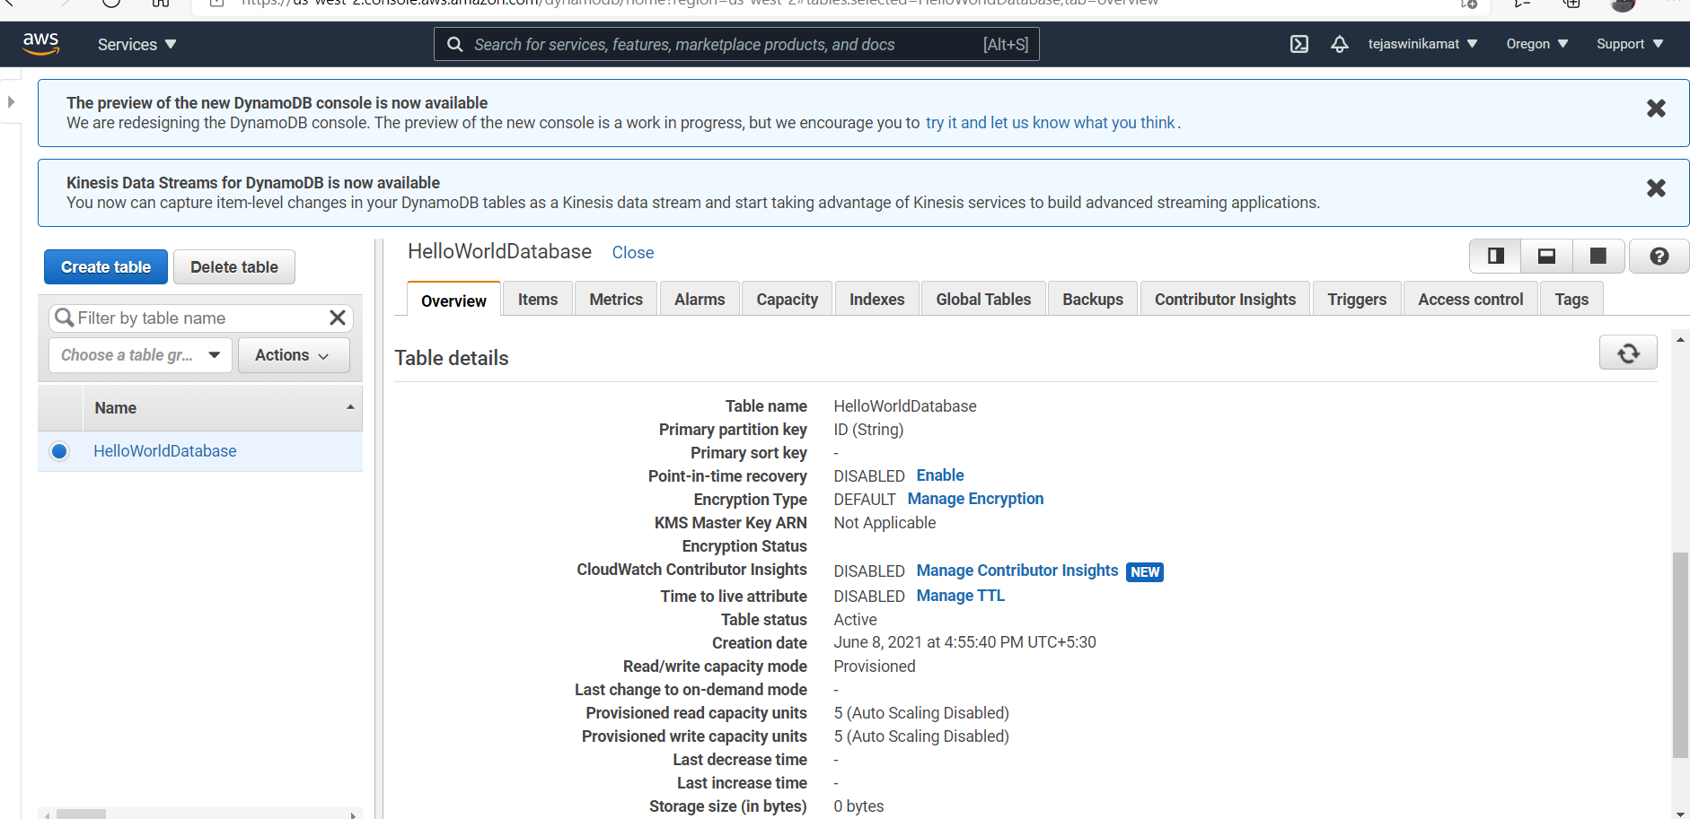

Step 5: Added interactivity to Web App and redeployed changes to AWS

Updated the web app index.html. Added code to access the API which in turn stores access timestamp entry into DynamoDB via the AWS Function. Redeployed changes using AWS Console.

